Pokhara University

Level: Bachelor | Semester – Fall | Year : 2008
Programme: BE |  | Full Marks: 100
Course: Engineering Mathematics II |  | Time : 3hrs.

Candidates are required to give their answers in their own words as far as practicable.
The figures in the margin indicate full marks.

Attempt all the questions.

 | - Find the two points on the line 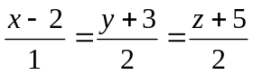either sides of the point (2,-3,-5) at a distance 3 from it.  - Find the equation of the sphere passing through ( 1,0,0) ,(0,1,0) and (0,0,1) and their radius as small as possible.  OR  Find equation of the sphere through the circle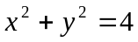, z = 0 and is cut by the plane 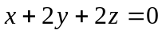in a circle of radius 3. | 7  8  8
 | - Find the minimum value of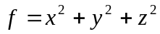, such that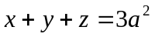.  OR  State and prove Eulers theorem of the function of x,y,z with degree n.  - If 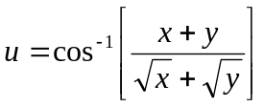, then find the value of 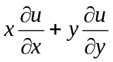 | 8  7
 | - Sketch the region of integration and evaluate the integral by reversing the order of integration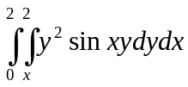.  - Find the volume in the first octant bounded by the coordinate planes, the cylinder and the plane z + y = 3. | 8  7
 | - Define order and degree of the differential equation with suitable example. Check exactness condition of the differential equation: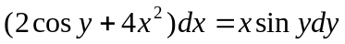, if it is not exact find integrating factor(IF) and then solve it by using IF.  - Solve : 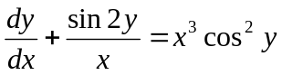. | 8  7
 | - Solve by power series method y" + y = 0.  OR  Write the Bessels function of first kind of order n. Prove that  d/dx [x^{n} J_{n} (x)] = x^{n} J_{n-1} (x).  - Solve the following initial value problem  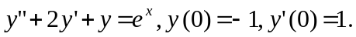 | 7  7  8
 | - Define Laplace transform of any function. Find 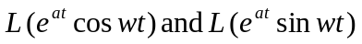  - Using the method of Laplace transform, solve the initial value problem | 8  7
 | Solve the followings:  - What is the condition satisfied by the equation of a cone to have three mutually perpendicular generators.  - Find the direction cosines of the normal to the plane x + 2y – 2z = 5.  - Solve (x + 1)y' = x(y² + 1).  - Write the Legendre’s polynomial of first kind.  - Verify Euler’s theorem for the function f = ax² + 2hxy + by². | 5×2

